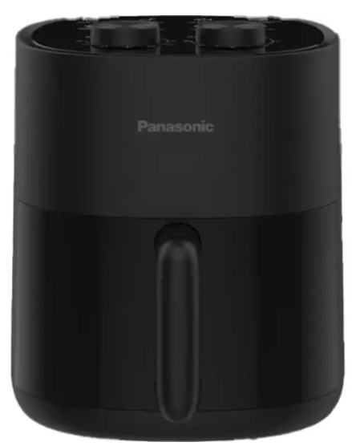

Panasonic Air Fryer
Rs.59,000
A Panasonic air fryer is a modern kitchen appliance that cooks food using rapid hot air circulation, allowing you to enjoy crispy meals with little or no oil, making cooking healthier and faster.

Specifications
- Power: ~1200W – 1450W
- Capacity: 4.5L – 6L (up to 9.6L in advanced models)
- Temperature Range: 80°C – 200°C
- Voltage: 220–240V

Key Features
- Rapid Air Circulation Technology
- Low-Oil Cooking
- Auto Shut-Off & Safety System
- Large Capacity Basket (4.5L – 6L+)

